Unit 3 Question Packet Name …………………………………………
Atoms, Ions, & Isotopes Period ………….

Skills
1. interpreting Models of the Atom
2. determining # of subatomic particles
in Atoms
3. identifying Ground-state & Excited-state Electron Configurations
4. interpreting Isotopic Notation
5. Calculating Atomic Mass
6. determining # of subatomic particles
in Ions

Skill #1: interpreting Models of the Atom - refer to your notes and RB p. 33-34

1. One model of the atom states that atoms are tiny particles composed of a uniform mixture of positive and negative charges. Scientists conducted an experiment where alpha particles were aimed at a thin layer of gold atoms.
Most of the alpha particles passed directly through the gold atoms. A few alpha particles were deflected from their straight-line paths. An illustration of the experiment is shown below.

- Most of the alpha particles passed directly through the gold atoms undisturbed. What does this evidence suggest about the structure of the gold atoms?
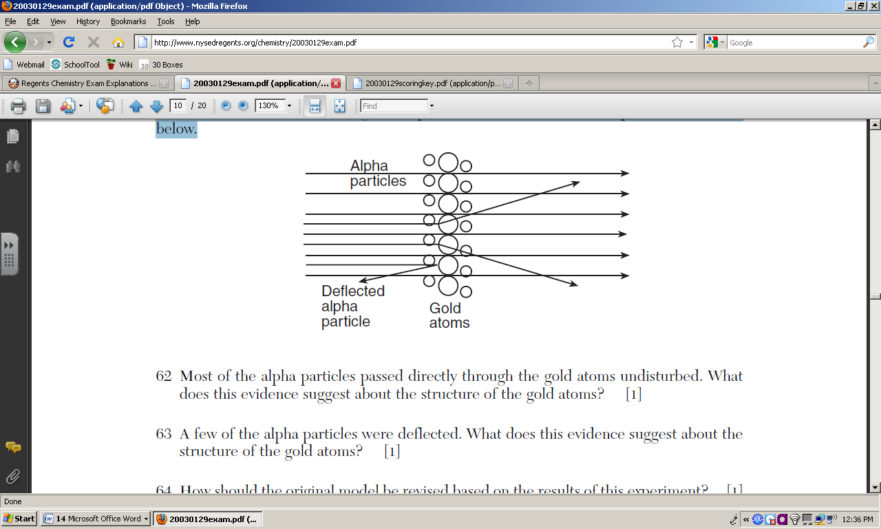

- A few of the alpha particles were deflected. What does this evidence suggest about the structure of the gold atoms?

- How should the original model be revised based on the results of this experiment?
The atom has a positively charged nucleus; negative electrons surround the outside.
The positive charges are in the nucleus; electrons are not mixed in the nucleus.
nucleus smaller than atom

2. In 1897, J. J. Thomson demonstrated in an experiment that cathode rays were deflected by an electric field. This suggested that cathode rays were composed of negatively charged particles found in all atoms. Thomson concluded that the atom was a positively charged sphere of almost uniform density in which negatively charged particles were embedded. The total negative charge in the atom was balanced by the positive charge, making the atom electrically neutral.
In the early 1900s, Ernest Rutherford bombarded a very thin sheet of gold foil with alpha particles. After interpreting the results of the gold foil experiment, Rutherford proposed a more sophisticated model of the atom.

a. State one conclusion from Rutherford’s experiment that contradicts one conclusion made by Thomson.
An atom has a nucleus that is positively charged; An atom is mostly empty space.
Negatively charged particles are located outside the positive nucleus.

b. State one aspect of the modern model of the atom that agrees with a conclusion made by Thomson.
An atom has equal amounts of negative and positive charge.
An atom has an equal number of protons and electrons.
All atoms contain electrons.
Electrons are negatively charged.
Skill #2: determining # of subatomic particles - refer to your notes, RB p. 35-37, Table S,
and the Periodic Table

3. Complete the table below based on information provided for each atom.
Remember: all atoms are electrically neutral (no charge, so # protons = # of electrons)
Atom | Protons | Electrons | Neutrons | Mass  # | Atomic # | Nuclear charge | # of Nucleons | Nuclear diagram | Element’s Symbol
A | 44 | 44 | 58 | 102 | 44 | +44 | 102 | 58 n  44 p | Ru
B | 84 | 84 | 125 | 209 | 84 | +84 | 209 | 125 n  84 p | Po
C |  |  |  | 56 |  |  |  |  | Mn
D |  |  |  |  | 89 |  | 229
E |  |  | 30 |  |  | +28
F |  | 92 |  |  |  |  | 233
G |  |  | 82 |  |  |  |  |  | Ba

- in the second and third shells shows that this atom is in an excited state.

7.
Skill #4: Interpreting Isotopic Notation – refer to your notes and RB p. 38

8. Copper has two naturally-occuring isotopes, Cu-63 and Cu-65. State, in terms of subatomic particles, how an atom of Cu-63 differs from an atom of Cu-65.

Skill #5: Calculating Atomic Mass – refer to your notes and RB p. 39

10. Calculate the atomic mass for each element below, given the relative abundances and the mass numbers of the isotopes. Show ALL work. (GSSC)

- 19.78% of B-10
80.22% of B-11 S: decimal x mass = products (add)
S: 0.1978 x 10 = 1.978
0.8022 x 11 = 8.8242
10.80 amu
C: 10.80 is between 10 and 11, closer to 11 (80%)

- 78.70% of Mg-24
10.13% of Mg-25
11.17% of Mg-26 S: 0.7870 x 24 = 18.888
0.1013 x 25 = 2.5325
0.1117 x 26 = 2.9042
24.32 amu
C: 24.32 is between 24 and 26, closer to 24 (79%)

- 93.12% of K-39
6.88% of K-41 S: decimal x mass = products (add)
S: 0.9312 x 39 = 36.3168
0.0688 x 41 = 2.8208
39.1 amu
12. Naturally occurring elemental carbon is a mixture of isotopes. The percent composition of the two most abundant isotopes is listed below.
• 98.93% of the carbon atoms have a mass of 12.00 atomic mass units.
• 1.07% of the carbon atoms have a mass of 13.00 atomic mass units.

- Show a correct numerical setup for calculating the average atomic mass of carbon.
S: decimal x mass = products (add)
S: 0.9893 x 12.00 = 11.8716
0.0107 x 13.00 = 0.1391
12.01 amu
C: 12.01 is beween 12 and 13, closer to 12 (99%)

- Describe, in terms of subatomic particles found in the nucleus, one difference between the nuclei of carbon-12 atoms and the nuclei of carbon-13 atoms. The response must include both isotopes.

13. The atomic mass of element A is 63.6 atomic mass units. The only naturally occurring isotopes of element A are A-63 and A-65. The percent abundances in a naturally occurring sample of element A are closest to
(1) 31% A-63 and 69% A-65 (2) 50% A-63 and 50% A-65
(3) 69% A-63 and 31% A-65 (4) 100% A-63 and 0% A-65
14. A 100.00-gram sample of naturally occurring boron contains 19.78 grams of boron-10 (atomic mass = 10.01 atomic mass units) and 80.22 grams of boron-11 (atomic mass = 11.01 atomic mass units). Which numerical setup can be used to determine the atomic mass of naturally occurring boron?
Skill #6: Determining # of subatomic particles – refer to your notes, RB p. 44-45, & P.T.
in Ions

15. Complete the table below.
Ion | Charge | # of protons | # of electrons | Electron configuration | E.C. same as… | Ion larger or smaller than atom?
Al³⁺ | +3 | 13 | 10 | 2-8 | Ne | smaller
P³⁻
Sr²⁺
Na⁺ | +1
 | +2 | 12
 | +1 | 1 | 0 | 0 | a proton
 | -2 | 8
 | -1 | 17
K⁺
F⁻

16. Explain, in terms of subatomic particles, why an oxygen atom is electrically neutral.

17. Explain, in terms of subatomic particles, why an oxide ion, O²⁻, has a negative charge.

18. Compare the number of protons to the number of electrons in a positive ion.

19. Compare the number of protons to the number of electrons in a negative ion.

20. Explain, in terms of subatomic particles, why a chlorine ion is larger than a chlorine atom.

